How to Access Mattermost
Here is the link to create a username and password in Mattermost
https://americanstatenationals.us/mattermost/signup_user_complete/?id=rhd8dcj1qjgkffcqo3wxu55w3y
Once you have created your username and password go to the link below to login
https://americanstatenationals.us/mattermost/
Then you will need to add channels. Please see the picture below. to see how to do that. Locate the Channels you wish to participate in and join each one.
Some Channels are private and you will need to ask permission to join any private channel.

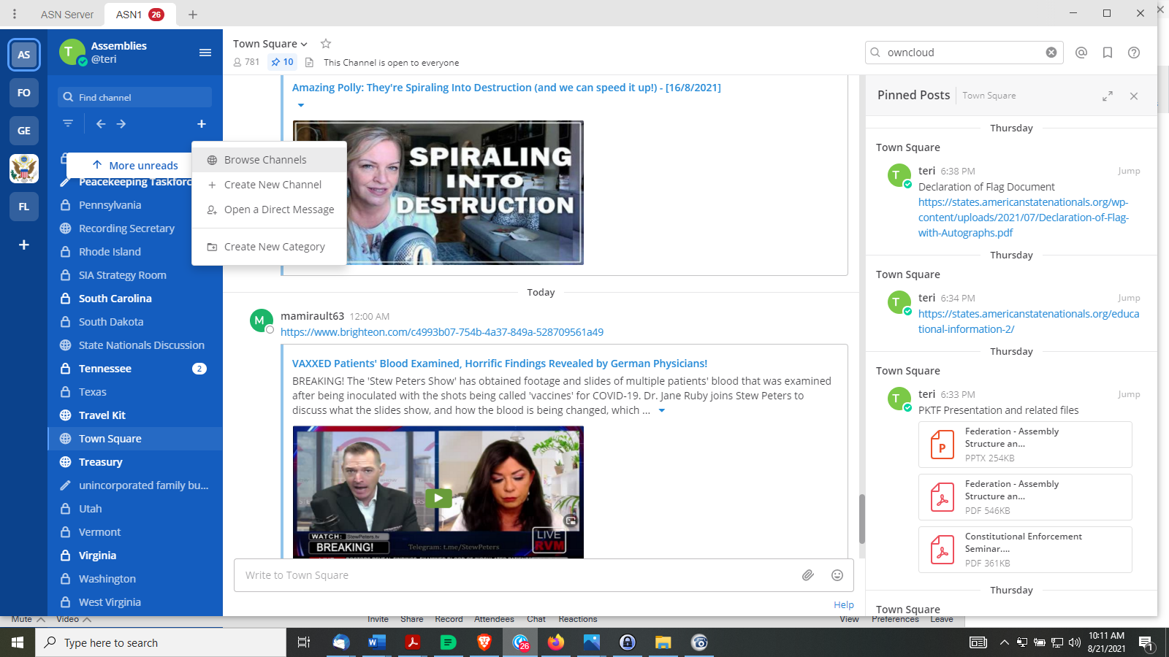
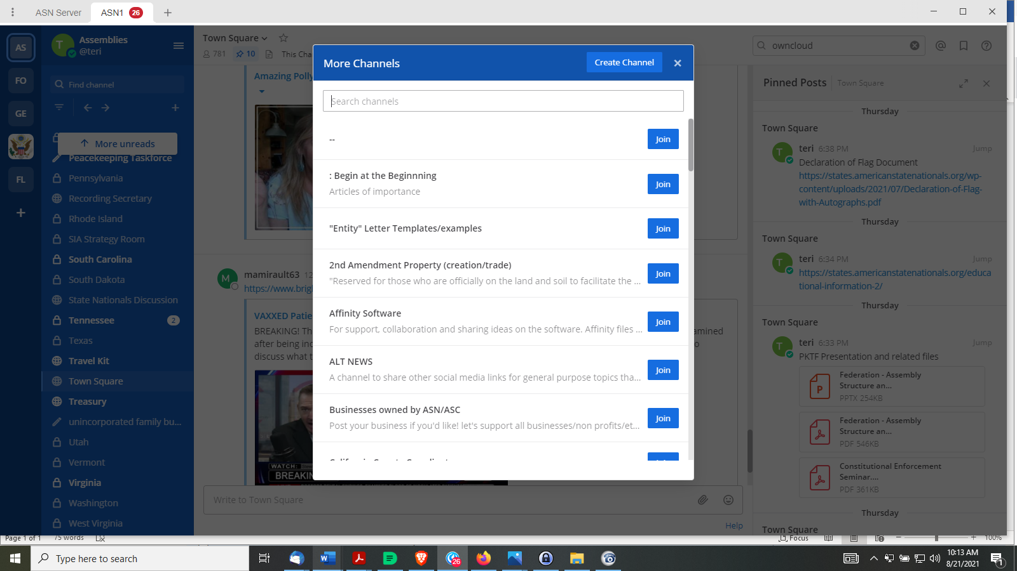

Look for “Pinned Posts”

In the upper left corner, under the name of the channel, you will see a little pushpin.

Click on that to have all the pinned posts come up on the right side of the screen.

